The Fallacy of the Unchanging Human Heart: A Preface to Paradise Lost (1942)
Poetry and Meaning
“Mythology is the ghost of concrete meaning. Connections between discrete phenomena, connections which are now apprehended as metaphor, were once perceived as immediate realities. . . . As we go back in history, language becomes more picturesque, until its infancy, when it is all poetry; or all spiritual facts are represented by natural symbols.”—Owen Barfield, Poetic Diction (1928)
“Virgil, like every great poet, is no doubt economic in fact (‘no word he wrote in vain’) but the impression he produces is one of lavishness—as of a rich wine swelled above the brim of the glass. He is full of echoes and vistas and partial repetitions”—Lewis, English Literature in the Sixteenth Century
Owen Barfield held that human language is inherently metaphoric, that there is no primitive literal stage (such as that held by the early philologist/ anthropologist Max Müller); rather, language in its origins was always a close bundle between metaphoric models and object descriptors. Only later generations learn to use more abstract language, and even then, the original metaphors are still latent in the abstract. The first written histories, therefore, were still infused with much of what we might dismiss as mythology. Much scientific reflection, he would hold is simply “fossilized metaphor.” And he held that science advances as much through new metaphors that break open new meanings.
Barfield held that the earliest works show an absolute poetic creation of meaning, while later generations through reflection of this creation would find a more abstracted awareness of the process. The former understand by living what they enact, the later understand by stepping back to analyze. Yet these suggest two different kinds of knowing. The one is enlivened, while the other is simply a method of testing. Barfield sees this as having historical consequences. Classical poets, for example, began by seeing themselves as possessed by the gods, then later by being inspired by the Muses; the poets eventually came to see their muse as psychological: simply having a division within themselves in which inspiration acts on the poetic faculties, and finally we come in our own time to inspiration as simply nothing more than a modern mood or feeling.
Lewis adopted some of Barfield’s central insights, though he was cautious not to adopt Barfield’s heterodox anthroposophy. At first, Lewis was reluctant to agree with Barfield that one could describe physical objects only with metaphors, though he may have come to eventually agree even here. Nonetheless, he was intrigued by the notion of an ancient state in which the poetic and the prosaic were not yet separate. Lewis also wanted to hold out a space for reason and logic that was not reducible to the metaphoric, for Lewis was never entirely sympathetic to the changes that would come to philosophy with Ludwig Wittgenstein. Nonetheless, Lewis’ description of Adam and Satan in A Preface to Paradise Lost parallels Barfield’s distinction, as does Lewis’ picture of language in the Ransom (i.e. Space) Trilogy and its characterization in Till We Have Faces.
Lewis and “The Reality Principle”
Gilbert Meilaender argues that the “reality principle” at the heart of Lewis’ ethics is a basic question of metaphysical and ethical sovereignty. As Lewis puts it in The Problem of Pain: “They [Adam and Eve] wanted, as we say, to ‘call their souls their own’, But this means to live a lie, for our souls are not, in fact, our own.” One of the chief moral dangers of ownership is the desire to continually repeat one pleasure rather than accept the whole process of anticipation-experience-remembrance. Gratitude is tied to giving up dominance of the experience, to embracing a dialectic of reception and renunciation. The world must be enjoyed as God-given, but it must also not be clutched too tightly.
Comprehension Questions for Chapters I-II
- According to Lewis, why is it that many modern readers of poetry soon give up on reading Milton’s epic poetry?
- Why is it important that a reader of Paradise Lost understands the basic form of the (secondary) epic?
- Why does he see the supposed tension between biblical and classical sources in Milton as something more like a fusion?
- At the same time, Lewis identified in Milton three important tensions: a) the classical and romantic; b) that of liberty and discipline; and c) the erotic and the chaste. Speculate. Why would these tensions be important for understanding Milton?
- What is the position that T.S. Eliot took that Lewis wanted to reject?
- How does Lewis seek to reduce this position to an extreme?
- How does Lewis separate out the moral, rational, and practical spheres as distinctly different from the creative and critical?
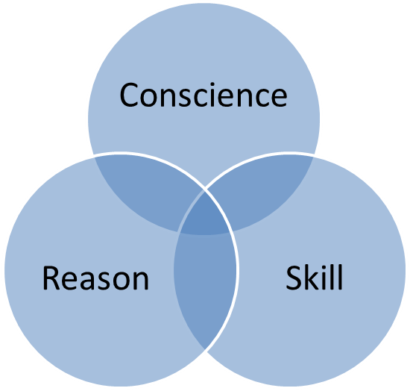
Insight
Performance
Production
Insight, Performance and Production interrelate in the purpose or telos of the work

Comprehension Questions for Chapter XIX
- Why does Lewis think the last two books of Paradise Lost is a structural flaw in the epic poem?
- Why is the literary character of God the Father in the poem weak on poetic grounds and not necessarily theological ones?
- Why does Lewis (following Charles Williams) hold that the literary figure of the Son is more successful?
- Why is it important to see Paradise Lost as a cosmo-theological poem rather than a religio-contemplative one?
- Why does Lewis hold that Milton need not be held up to the standard of Dante?
- Why is the tradition of Romantic criticism beginning with William Blake mistaken about the poem?
- Of the four classes of critics that are not sympathetic to the poem’s style, which do you think Lewis is the least condemnatory?
- Why in particular does Lewis insist that stream-of-consciousness is as artificial a way of engaging our experience of phenomena as is the highly organized and selective approach of the epic?

Those like Leavis | These understand the style; they simply hate it, and perhaps its view of humanity and joy.
Those who envy & fear its “wall” | These refuse to take the time to engage the poem on its terms of organization and “civility.”
Those who embrace an alternate realism | These hold the stream-of-consciousness technique of James Joyce to be more authentic in picturing the state of the mind.
Those like Eliot | These want to travel outside the city to the via negativa (the way of negation or emptiness) of poetry.

