Auden in the Late 30s (1): Four Poems about Brussels
The following four poems reflect on the ways in which daily life, especially urban life, buffer and attempt to protect some from the suffering of others. The form can take that of a class-based segregation, a task-based psychological need, or a sinister political mystery. These poems show Auden focusing on both political and moral matters, and as such, they squint back-and-forth between the two, subtly implying blurry links between them.
“The Capital” (CP 177-178)
- How do the first three stanzas contrast with the last two?
- What are the temptations and deceptions of the riches, heating, and lighting of the modern Brussels?
- What is Auden suggesting about urban life?
“Brussels in Winter” (CP 178)
- How can a place lose its certainty for someone?
- Why do some keep a “sense of place”?
- Why do a phrase and a look reveal much about humanity?
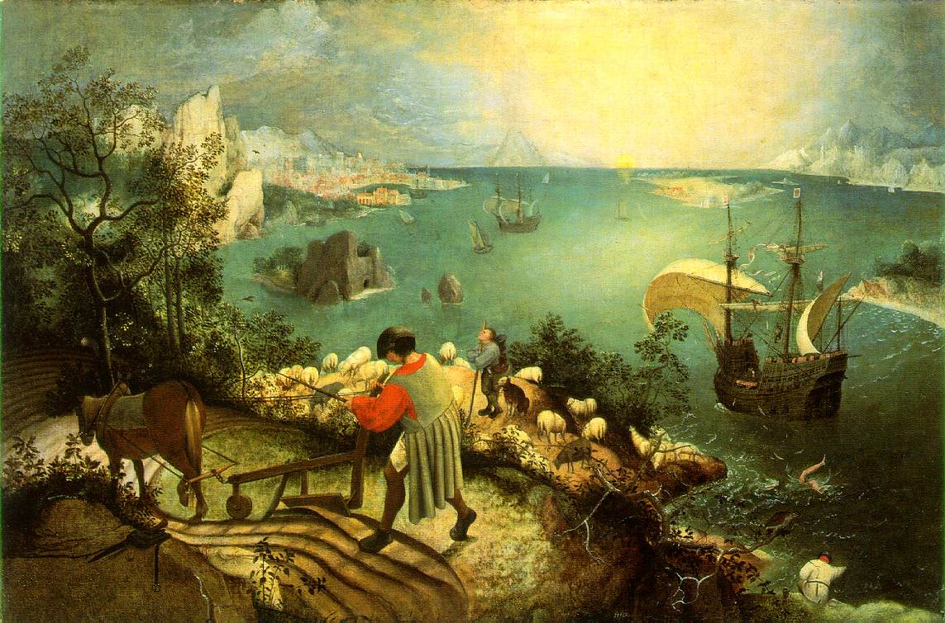

“Musée des Beaux Arts” (CP 179) [“Museum of Fine Arts’]
- How does “the human position” (or earthly life in general) exist alongside suffering or events of note?
- How does Pieter Brueghel’s Landscape with the Fall of Icarus in particular exemplify this contrast?
- Does Auden’s reading exhaust the meaning of the painting itself?
- Why does Auden title the poem as he does?
“Gare du Midi” (CP 180)
Gare du Midi: a train station in Brussels
- Why is this poem so short? How does its economy of form help reinforce its message?
- How would you characterize the bureaucrat who come “to infect the city”?
- How does the poem achieve its effect through leaving things unclear?

“If the way is hard to practice in the scientific field, how immensely more difficult is it to do so in the cultural and political. Democracy asserts that the private and public life are one, and at the same time that the individual has free-will. What most people think of as democracy is really social atomism and Mandevillism, for they imagine that private vices will not damage the general life but somehow cancel each other out. This mistake ends inevitably in the absolute nihilism disguised as Hegelianism . . . . Frankly, democracy will only work if as individuals we lead good lives, and we shall only do that if we have faith that it is possible and at the same time an acute awareness of how weak and corrupted we are.”—The Nation 7 October 1939

